Name: ________________________ Date: ________________

**Task 5: Gene therapy- Validation ANS ____ / 25**

Figure 2 below shows changes in hemoglobin over time in (g/dl) in a patient with Beta Thalassemia who received the CTX001 infusion

**Figure 2**

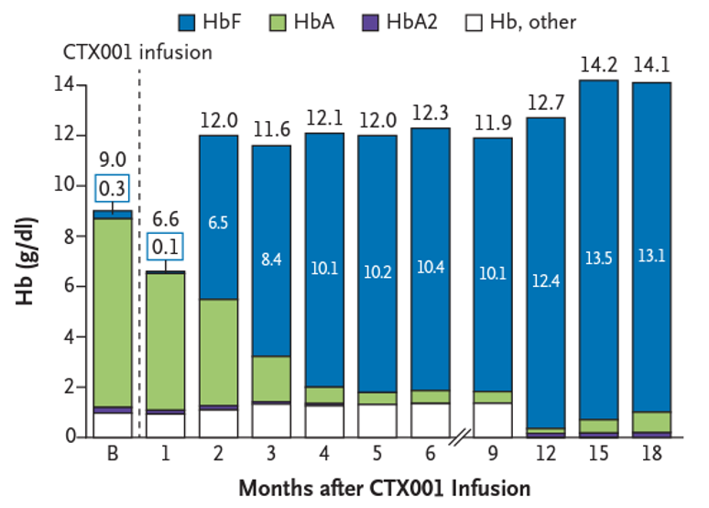

1. Use table below to calculate the Percentage Change (%) between Patients A and B for Month 5 and 6. (2 marks)

|  |  |  |  |
| --- | --- | --- | --- |
| **Month after Infusion** | **Patient A (% HbF)** | **Patient B (% HbF)** | **Percentage % Diff** |
| 1 | 0.8 | 1.5 | 0.7 |
| 2 | 25.9 | 54.2 | 29.2 |
| 3 | 37.2 | 72.4 | 35.2 |
| 4 | 46.6 | 83.5 | 36.9 |
| 5 | 48.6 | 85 | 36.4 |
| 6 | 47.3 | 84.6 | 37.3 |

**1 mark each**

1. With reference to the data provided for patient A and B, state two conclusions that can be drawn from the trial (2 marks)

|  |
| --- |
|  |
| Two of the following |
| Any valid trend (0.5 mark per trend) Uses data to support trend identified (0.5 mark per trend) |

1. Explain the level of confidence you would have in recommending CTX001 treatment based on these study results (2 marks)

Low level of confidence (1 mark) due to small sample size (1 mark)

1. After considering the data and your conclusions, what treatment advice would you provide to a patient with sickle cell anemia?

Explain your response, referring to data in Figure 1. (3 marks)

I would not recommend treatment with CTX001 **(1 mark)**

Despite seeing an increase in HbF of 46.5% ……**(1 mark)**

there was an immediate decrease in sickled hemoglobin of around 50% of total hemogobin but this then this increased over the 12 months of be 20% below original levels**. (1 mark)**

1. Propose two changes that could be made to the study’s experimental design to improve the reliability or validity of data collected.

In your answer, identify if this change increases reliability or validity and then describe how this occurs. (6 marks)

**Two ideas proposed- each idea worth 3 marks.**

* **1 mark** Change proposed.
* **1 mark** identify if it would improve reliability or validity.
* **1 mark** description of why it would improve reliability or validity of data.

|  |  |  |
| --- | --- | --- |
| **Change to methodology** | **Increases reliability or validity** | **Why** |
| Increase in sample size | Validity  Reliability | This would allow you to evaluate if this treatment would likely be effective in a larger population with differing presentations of SCA and BT.  This would allow them to me more confident in their results |
| Increase age range of participants in trial | Validity | This would allow scientists to identify if this gene editing is effective on younger and older patients |
| Compare with control  (someone who had similar baseline measurement of HbF) | Validity | To identify how must of an impact this has |
| Increase monitoring time beyond 15months | Validity | This would allow scientists to identify if changes in HbF lasted over a longer period of time which would inform if it is likely to be successful over patients life time |

**Any other change to methodology to improve reliability or validity with acceptable reasoning**

1. Within one family it is common to find multiple individuals who have a mutation that cause sickle cell anemia and beta thalassemia.

What does this tell you about where the original mutation occurred? Justify your response.

(2 marks)

It occurred in the cells that produce the gamete (germline)/germline cell (1 mark)

Only mutations produced in these cells can be inherited/passed on (1 mark)

Both variants of thalassemia, alpha and beta thalassemia provide resistance to malaria. Variants of alpha thalassemia provides resistance to malaria with little clinical complication whereas most beta thalassemia variants have significant effects on health. These effects include changes to the skeleton growth, iron overload and death from infection.

1. Describe how the link between the alpha thalassemia allele and malaria can lead to changes in the allele frequencies in a population. (4 marks)

Malaria reduces reproduction of normal cell individuals **(1 mark)**

Sickle-cell allele selected for/favoured **(1 mark)**

Carriers of sickle cell reproduce at greater rates **(1 mark)**

Sickle cell trait allele combinations increase/allele frequency of sickle cell increases **(1 mark)**

1. Describe mechanisms underpinning the theory of natural selection that produce changes in a gene pool. (4 marks)

